Assignment-17.1: Write a program that accepts the job_id as argument and returns a custom counter and a system counter (total records input to the map tasks) associated with that job.

Driver Class:

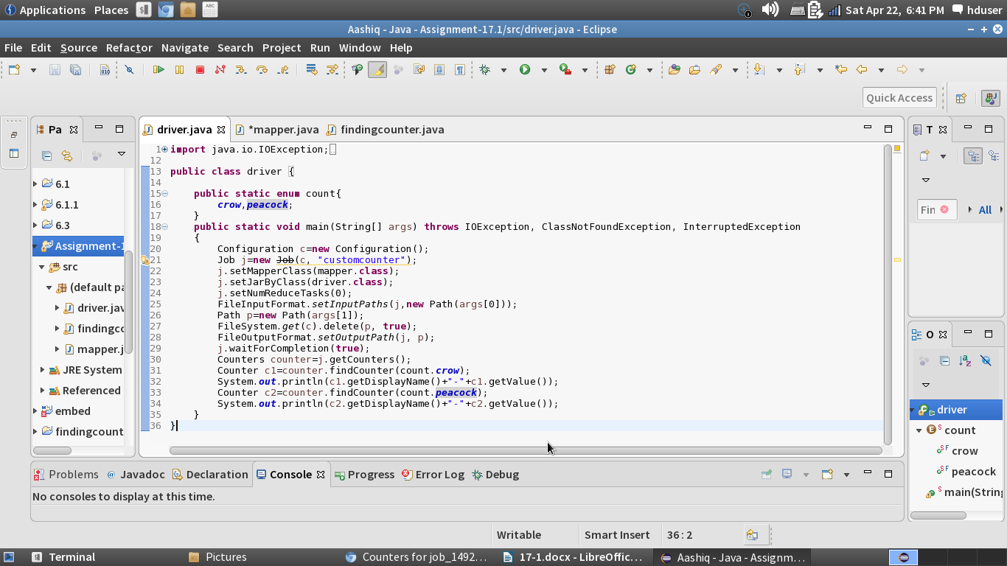

Mapper Class:

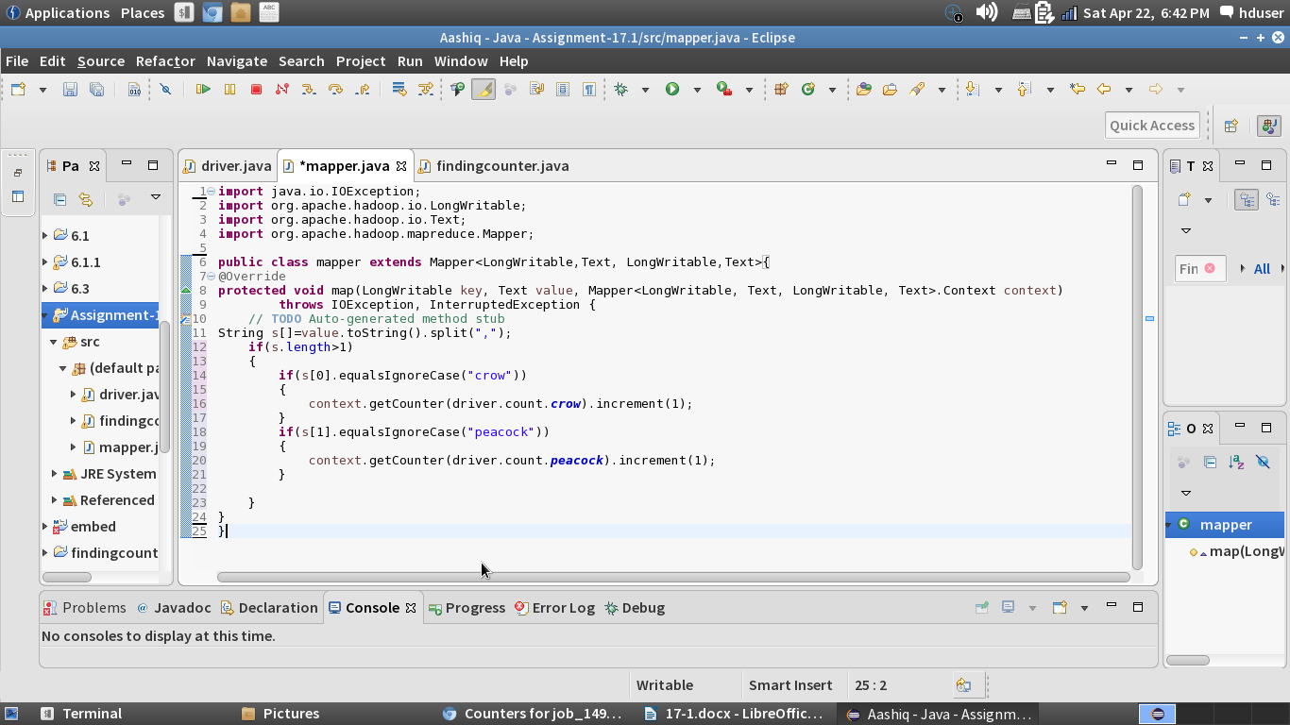

Running the jar File:

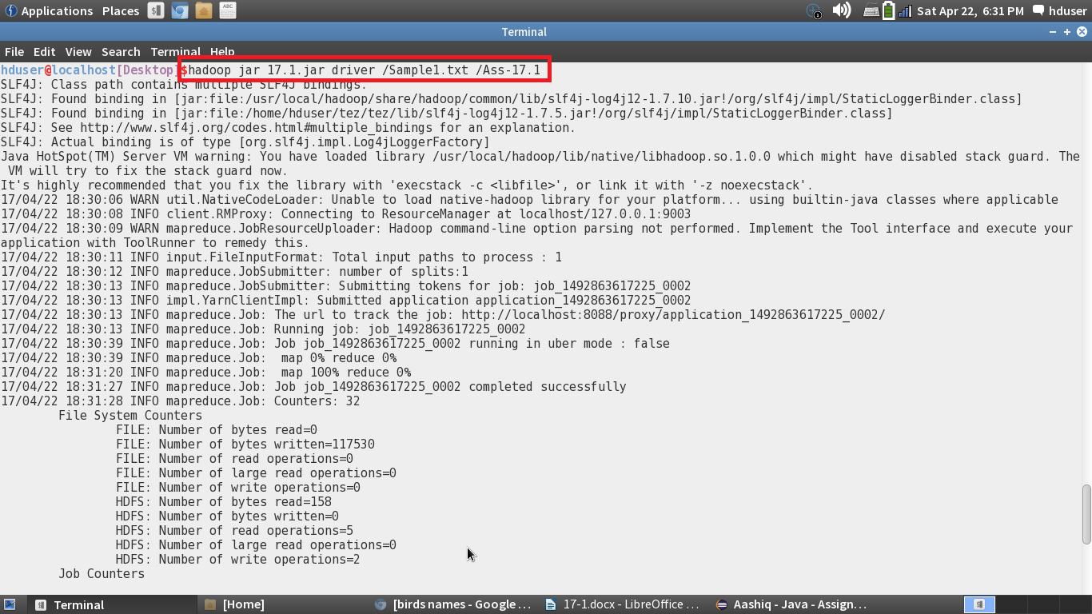

Job Succeeded in the JobHistory server:

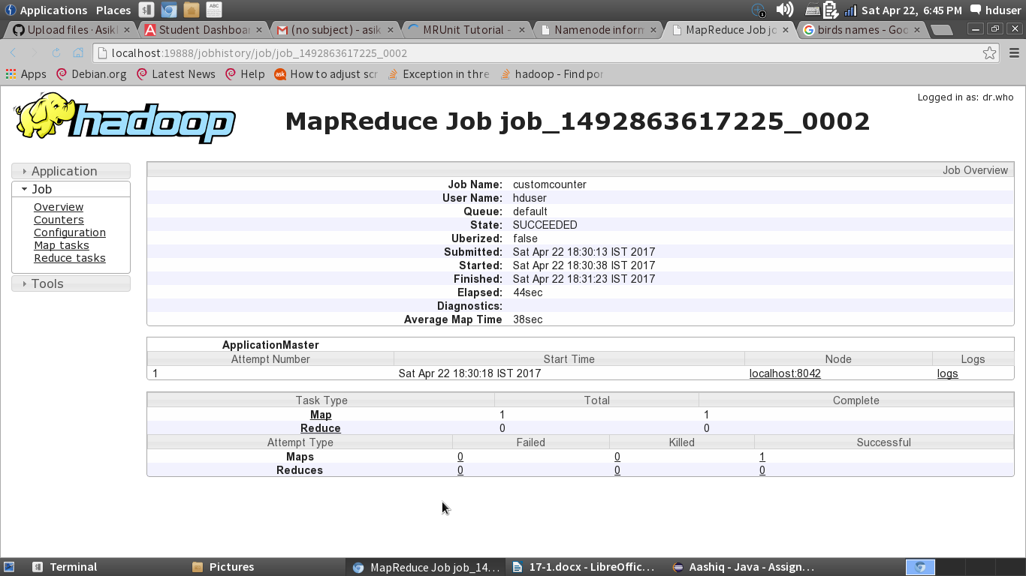

Custom Counter Generated:

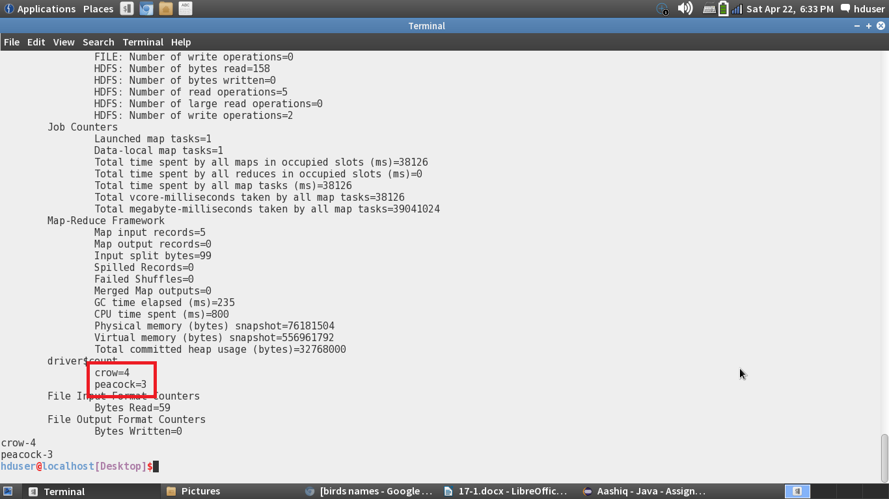

Job History Counter:

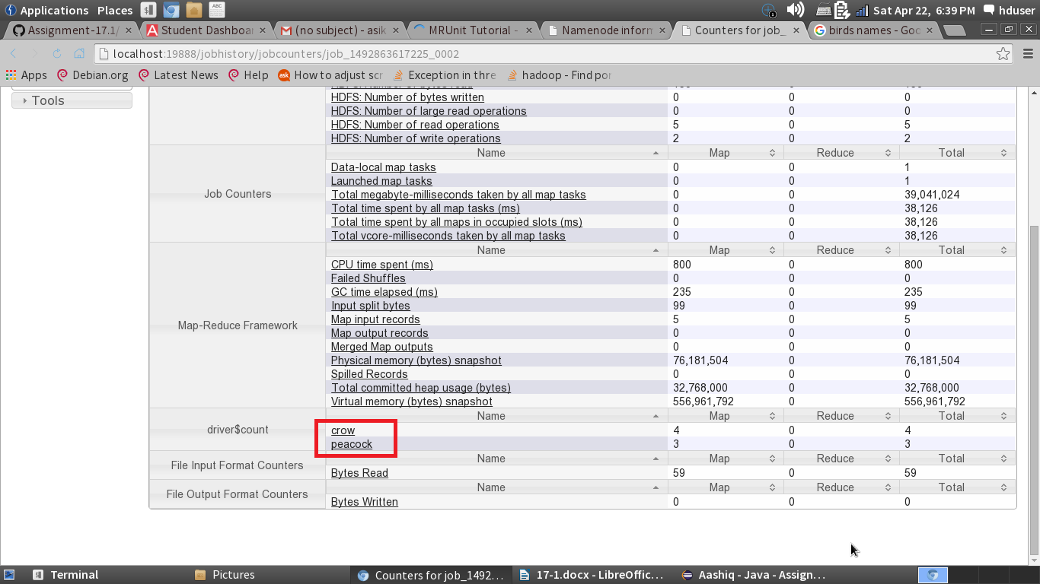

To give the Job ID as argument we need to create an Java Program that accepts the Job ID as the argument and gives the Custom counter and system counter as the output:

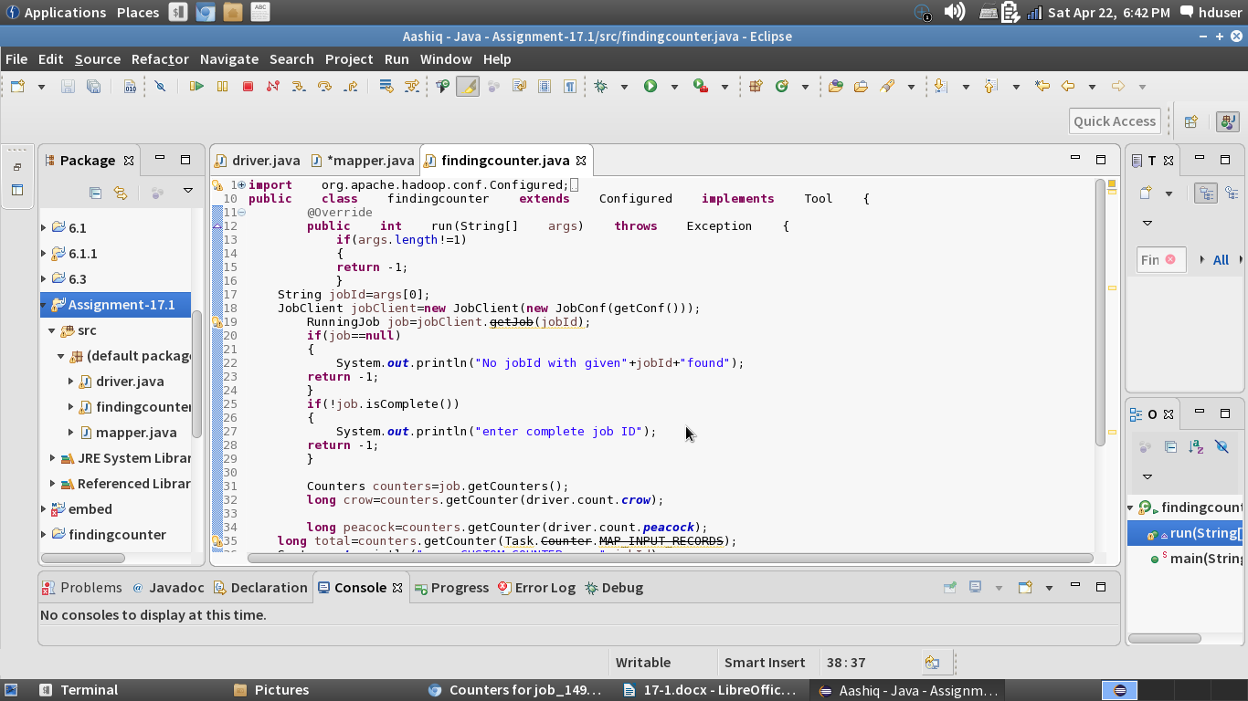

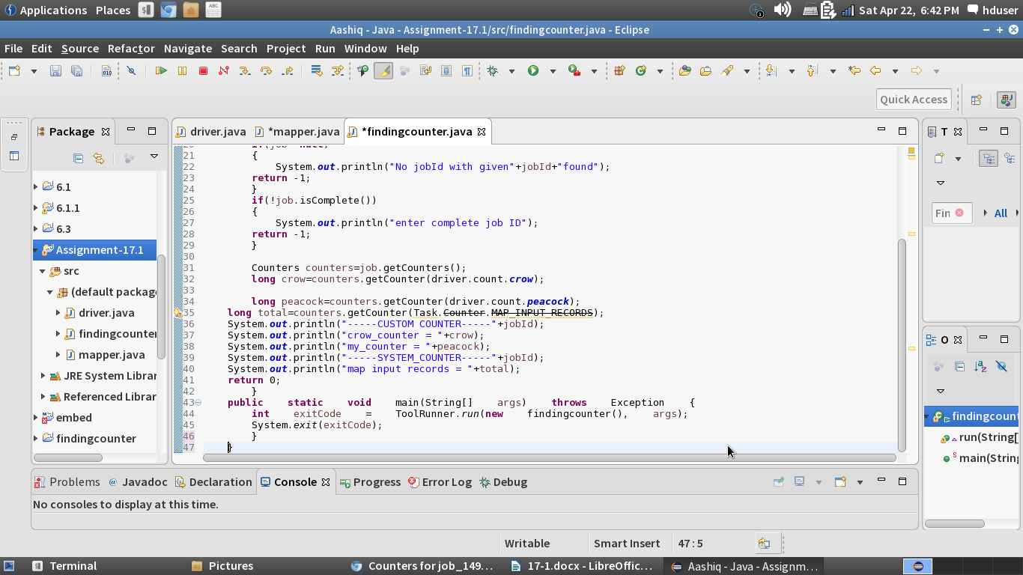

In this job we getting the job as the user input and checking if the job exists and if exists then checking if the job is completed or not and getting the custom counters as well as the task counter and displaying it.

Running the Jar File with Job ID as the argument:

